UNIVERSITY OF NEVADA LAS VEGAS – DEPARTMENT OF ELECTRICAL AND COMPUTER ENGINEERING



Design Assignment 4

CPE 301 Fall 2016

Luis Ruiz

**PART 0**

The assignment took me about 5 hours to do. I had to read the datasheet and debug a lot.

1. **PART A: Description**

**DC**

My design consists of a C program that drives a DC motor using PWM. The program takes advantage of Analog to Digital converter to read a voltage off a potentiometer that is creating a voltage divider with a resistor. The value of the resistor is 330 ohms as for the potentiometer, it has a max value of 2000 ohms. The program is very responsive to the change of voltage and outputs a PWM based off the voltage read in through the ADC. The logic used is very simple, once a voltage is read in the code has pre-established half way point which determines if the DC motor is to go forward or backwards. The speed of the motor is determined on the read in voltage if it is going forward, the higher the voltage the faster the motor; however, in the backwards direction, the lower the voltage read in the faster the motor goes.

**SERVO**

My design consists of a C program that drives a Servo motor using PWM. The program takes advantage of Analog to Digital converter to read a voltage off a potentiometer that is creating a voltage divider with a resistor. The value of the resistor is 330 ohms as for the potentiometer, it has a max value of 2000 ohms. The program is very responsive to the change of voltage and outputs a PWM based off the voltage read in. The voltage read is converted using a formula in order to get the range allowed in 180-degree servo motor. Based on the voltage read in, the C code then determines what PWM to output. This PWM is what determines the servo motors degree.

**PART B: Code**

**DC**

/*

* DA4_DC.c

*

* Created: 2/20/2017 2:08:50 PM

* Author : Luis

*/

#include <avr/io.h>

#include <util/delay.h>

#define *F_CPU* 16000000UL

unsigned short getADC(); //get the value read from ADC0

void initateTimer(); //initialize the Timer and set PWM with a 50Hz

void ADC0init(); //initialize ADC0 as an input

void update_OC1A(unsigned char); //update the value of the DC

int main(void)

{

//temporarily hold the value from the analog channel

unsigned short val;

//DUTY CYCLE

unsigned char DC;

//set the a nibble as output

DDRD = 0x0F;

ADC0init();

initateTimer();

while (1)

{

//Start conversion

ADCSRA |= (1 << ADSC);

//wait conversion to finish

while((ADCSRA & (1 << ADIF)) == 0);

//Get value that was converted

val = ADC;

if(val > 512)

{

//enable power to 1,2EN

//P.D0 and PD.1 for 1A HIGH and 2A LOW

//FOWARD

PORTD = 0x03;

//GET THE DUTY CYCLE BASED ON VOLTAGE IN

//Then update OC1A to put DC

DC = (unsigned char)((100.0*val)/1023);

update_OC1A(DC);

}

else

{

//enable power to 1,2EN

//P.D0 and PD.1 for 1A LOW and 2A HIGH

//BACKWARD

PORTD =0x05;

//GET THE DUTY CYCLE BASED ON VOLTAGE IN

//Then update OC1A to put DC

DC = (*uint8_t*)((100.0*(1023-val))/1024);

update_OC1A(DC);

}

*_delay_ms*(700);

}

return 0;

}

void initateTimer()

{

//Set PORTB1 pin as output

// make OC1A as output.

DDRB |= (1<<DDB1);

// Output compare mode on OC1A. Fast PWM with top = ICR1.

// Clear OC1A on Compare match and set at bottom.

TCCR1A |= (1<<COM1A1)|(0<<COM1A0)|(0<<COM1B1)|(0<<COM1B0)|(0<<FOC1A)|(0<<FOC1B)|(1<<WGM11)|(0<<WGM10);

// Start timer with pre-scaler 64

TCCR1B |= (0<<ICNC1)|(0<<ICES1)|(1<<WGM13)|(1<<WGM12)|(0<<CS12)|(1<<CS11)|(1<<CS10);

//TOP = (F_CPU / (N * F_pwm)) - 1, where N is the prescaler = 64, and F_pwm is the desired 50Hz frequency.

ICR1 = 4999;

}

void ADC0init()

{

DDRC &= ~(0<<DDC0); // SET PC.0 as an input

ADCSRA = 0x87; // Enable ADC and CLK/128

ADMUX = (1<<REFS0); // VCC reference, ADC0 single ended input

}

void update_OC1A(unsigned char DC)

{

//SET OC1A to create desire Duty Cycle based on the value passed in

OCR1A = (unsigned short)((DC * 4999.0)/100.0);

}

**Servo**

/*

* DA4_Ser.c

*

* Created: 2/20/2017 12:32:11 PM

* Author : Luis

*/

#include <avr/io.h>

#include <util/delay.h>

#define *F_CPU* 16000000L

#define SERV_MIN 97

#define SER_MAX 535

void initateTimer(); //initialize the Timer and set PWM with a 50Hz

void ADC0init(); //initialize ADC0 as an input

float position(unsigned short); //get the servo position

int main(void)

{

//temporarily hold the value from the analog channel

unsigned short val;

//get the value of Vin

float servo;

ADC0init();

initateTimer();

while (1)

{

//Start conversion

ADCSRA |= (1 << ADSC);

//wait conversion to finish

while((ADCSRA & (1 << ADIF)) == 0);

if(!(val == (ADCH<<1))){

//take the value from the upper bits of the ADC

val = ADCH<<1;

}

//Get the Vin being read

servo = position(val);

//this will determine the position

servo = (servo*438)+97;

//The OCR1A value is based on what value ADC0 is reading

//then develop a PWM based on ADC0 reading

if(servo < SERV_MIN)

OCR1A = SERV_MIN;

else

OCR1A = (int) servo;

}

return 0;

}

void initateTimer(){

//TOP = ((Focnx*N)/F_cpu)-1

//Desire Focnx = 50 Hz

ICR1 = 4999;

//ICR1 = (int)((16e6/(50*64))-1);

//SET Timer 1 to have the top to be ICR1

//FAST PWM reading the OCRA in non-inverting mode

//A prescalar of 64 => 16MHz / 64

TCCR1A = (1<<COM1A1)|(1<<WGM11);

TCCR1B = (1<<WGM13)|(1<<WGM12)|(1<<CS11)|(1<<CS10);

}

void ADC0init(){

//SET ADC0 as an input

DDRC |= (0<<PC0);

//PWM pin (OC1A)

DDRB |= (1<<PB1);

//SET AVcc with external capacitor at AREF

//and ADC0 as an input MUX[3:0] = 0b0000

ADMUX = 0x60;

//Turn on the ADC for conversion

//CLKadc/128 = ADPS[2:0] = 0b111

ADCSRA = 0x87;

//= (1<<ADEN)|(1<<ADPS2)|(1<<ADPS1)|(1<<ADPS0);

//Run in Free mode

ADCSRB = 0x0;

}

float position(unsigned short val){

//ADC = Vin*1024.0/Vref

//Vin = ADC * 5(Vref)/1024.0

return ((val*5)/1024.0);

}

**PART C:Flow Chart**

**DC**

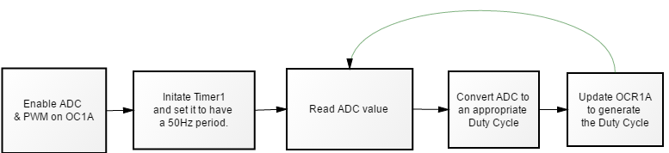

**Servo**

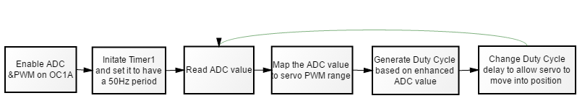

**PART D: Schematic**

**DC**

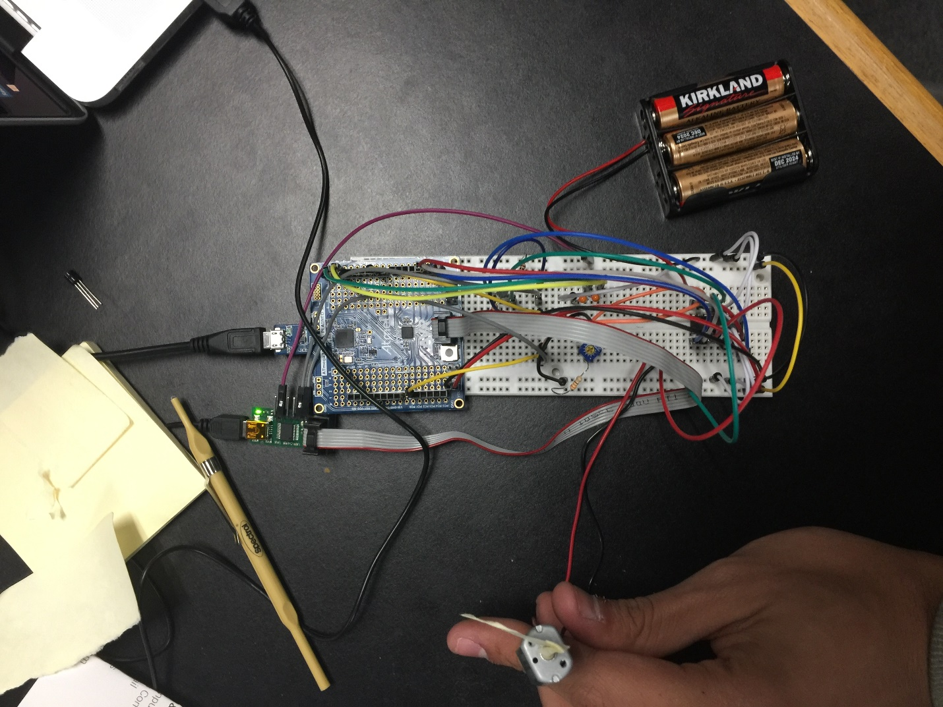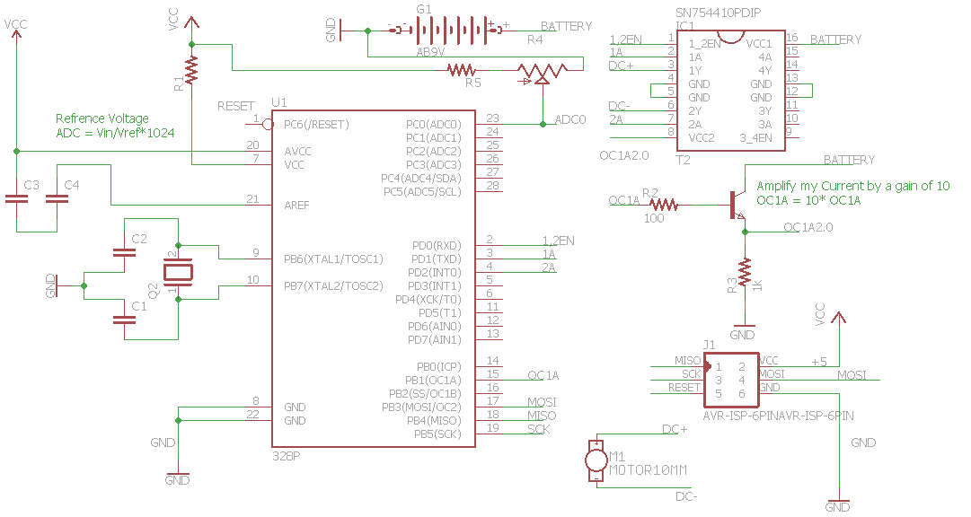

**Servo**

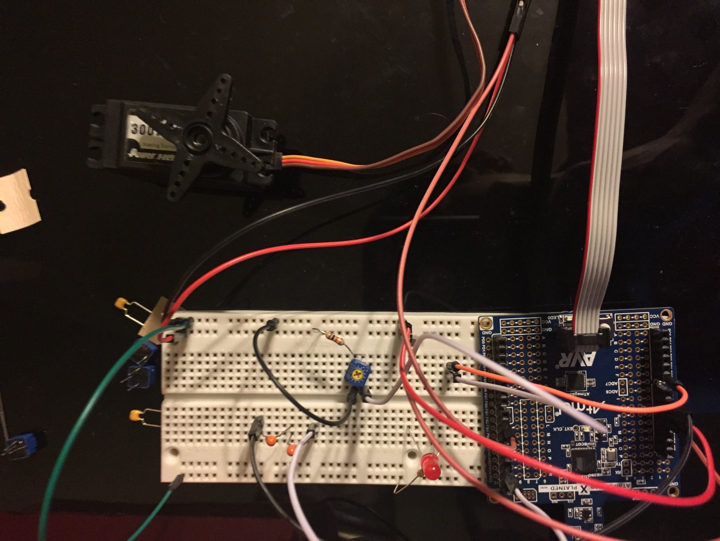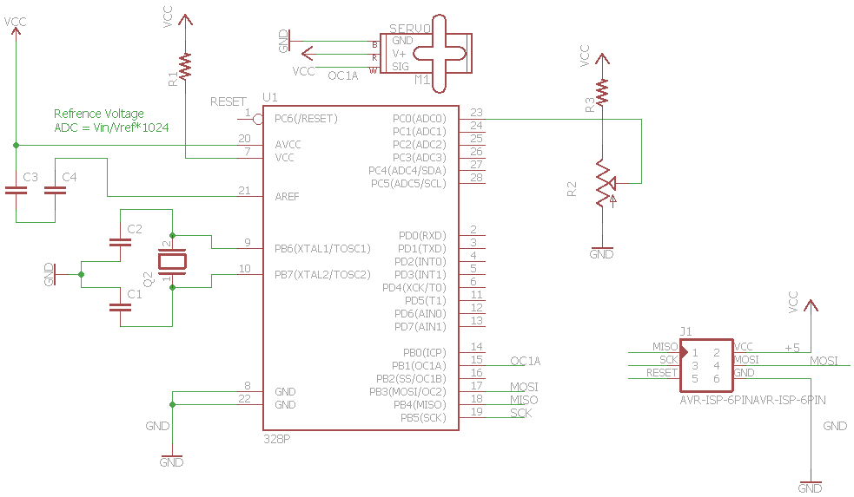

**PART E: Video**URL Video of Design Assignment 4: <https://youtu.be/ycIpYCUF2V0>